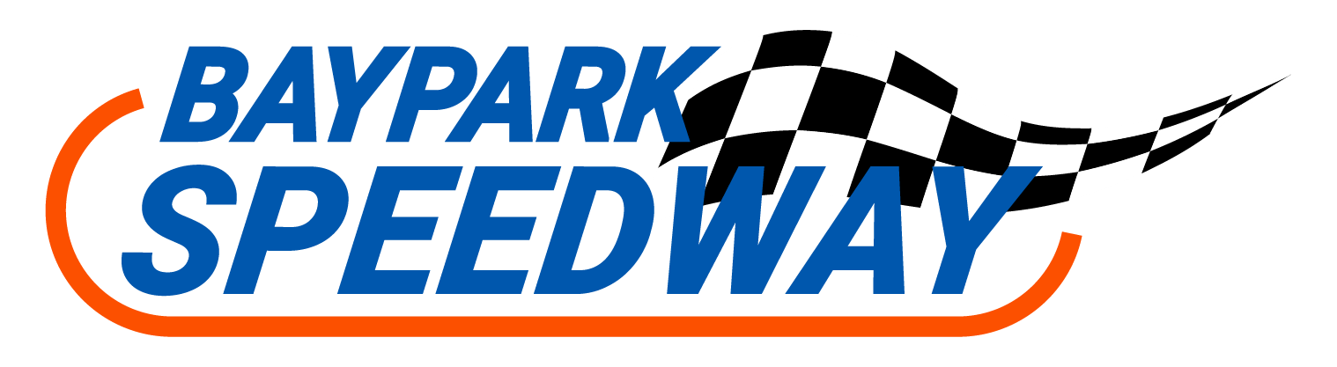

METAL MAN RECYCLERS DEMOLITION DERBAY

Saturday 07 January 2022
WIN $1000 & TROPHY!
ENTRY $100 non-refundable
FIRST, 50 CARS ACCEPTED
All fields with * are mandatory
NAME *_________________________________ PREFERRED CAR # *__________
ADDRESS * _________________________________ DATE OF BIRTH *__________
______________________________________________
OCCUPATION __________________________________ PHONE * __________________
EMAIL * ____________________________________________
CAR MAKE __________________________________ CAR MODEL _______________
• All drivers must purchase an SNZ one-day license on the day. One-day & Season Derby licenses are purchased online 😊 via https://www.speedway.co.nz/licences/licences-3
• Registered Demolition Derby Drivers will be entitled to one free entry on the day.
• All cars to be at the track no later than 3:00 pm for scrutineering. Pit Gates open at 12 noon.
• Cars must display their allocated race number prominently on the vehicle.
• The pit gate will be open from 9.00 am until 11:00 am on Sunday 8th January for the removal of race vehicles.
• Any race vehicle left after 11:00 am will be removed and disposed of by the promotion.
• The promotion reserves the right to reject or decline any entry or driver at their discretion.

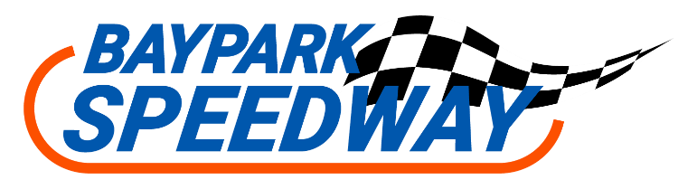

DECLARATION
• I have received a copy or viewed the Speedway New Zealand Inc Rules and Specifications for Demolition Derbies. Derby Technical & Racing Rules can be found here - https://www.speedway.co.nz/asset/downloadasset?id=a7ec8b88-de82-4e92-b046-751fe72a92f2

• I have read, and I understand the Speedway New Zealand Inc Rules and Specification for the Demolition Derby.

I agree to abide by the specified rules.
SIGNED ___________________________________________________ Competitor

Once your entry is received you will be sent an invoice for payment of the entry fee,
that must be paid to confirm your entry.

Winners’ prize money:
Will be paid to the winner’s nominated bank account.

IMPORTANT: Please send a copy of this completed entry form to bayparkinfo@bayparkspeedway.co.nz, no later than 2 weeks out from race date
or post to Baypark Speedway, PO Box 14327, Tauranga 3143.
Phone 07 574 2227
www.bayparkspeedway.co.nz

